**Trabajo Práctico N° 6:**

**Integrales.**

**Ejercicio 1.**

**(a)** *Si $\int_{0}^{9}{f (x) dx}$ = 37 y $\int_{0}^{9}{g (x) dx}$ = 16, encontrar el valor de $\int_{0}^{9}{2 f (x) -\frac{1}{4} g (x) dx}$.*

$\int_{0}^{9}{2 f (x)-\frac{1}{4} g (x) dx}$ = $\int_{0}^{9}{2 f (x) dx}$ + $\int_{0}^{9}{\frac{-1}{4} g (x) dx}$

$\int_{0}^{9}{2 f (x)-\frac{1}{4} g (x) dx}$ = 2 $\int_{0}^{9}{f (x) dx}$- $\frac{1}{4}$ $\int_{0}^{9}{g (x) dx}$

$\int_{0}^{9}{2 f (x)-\frac{1}{4} g (x) dx}$ = 2 * 37 - $\frac{1}{4}$* 16

$\int_{0}^{9}{2 f (x)-\frac{1}{4} g (x) dx}$ = 74 - 4

$\int_{0}^{9}{2 f (x)-\frac{1}{4} g (x) dx}$ = 70.

**(b)** *Si $\int_{-2}^{3}{h (x) dx}$ = 12 y $\int_{0}^{3}{h (x) dx}$ = 3, hallar el valor de $\int_{-2}^{0}{h (x) dx}$.*

$\int_{-2}^{0}{h (x) dx}$ = $\int_{-2}^{3}{h (x) dx}$- $\int_{0}^{3}{h (x) dx}$

$\int_{-2}^{0}{h (x) dx}$ = 12 - 3

$\int_{-2}^{0}{h (x) dx}$ = 9.

**(c)** *Si $\int_{-1}^{3}{f (t) dt}$ = 3 y $\int_{-1}^{4}{f (t) dt}$ = 7, determinar el valor de $\int_{3}^{4}{f (t) dt}$.*

$\int_{3}^{4}{f (t) dt}$ = $\int_{-1}^{4}{f (t) dt}$- $\int_{-1}^{3}{f (t) dt}$

$\int_{3}^{4}{f (t) dt}$ = 7 - 3

$\int_{3}^{4}{f (t) dt}$ = 4.

**Ejercicio 2.**

*Calcular las siguientes integrales utilizando las propiedades y, en caso de ser posible, usando la regla de Barrow.*

**(a) $\int_{-2}^{3}{2x-1 dx}$** *.*

$\int_{-2}^{3}{2x-1 dx}$ = $\int_{-2}^{3}{2x dx}$ + $\int_{-2}^{3}{-1 dx}$

$\int_{-2}^{3}{2x-1 dx}$ = 2 $\int_{-2}^{3}{x dx}$- $\int_{-2}^{3}{1 dx}$

$\int_{-2}^{3}{2x-1 dx}$ = 2 $\frac{x^{2}}{2}$ $|_{-2}^{3}$- x $|_{-2}^{3}$

$\int_{-2}^{3}{2x-1 dx}$ = $x^{2}$ $|_{-2}^{3}$- [3 - (-2)]

$\int_{-2}^{3}{2x-1 dx}$ = [ $3^{2}$- ${(-2)}^{2}$] - (3 + 2)

$\int_{-2}^{3}{2x-1 dx}$ = (9 - 4) - 5

$\int_{-2}^{3}{2x-1 dx}$ = 5 - 5

$\int_{-2}^{3}{2x-1 dx}$ = 0.

**(b) $\int{x^{2}+2x+8 dx}$** *.*

$\int{x^{2}+2x+8 dx}$ = $\int{x^{2} dx}$ + $\int{2x dx}$ + $\int{8 dx}$

$\int{x^{2}+2x+8 dx}$ = $\frac{x^{3}}{3}$ + 2 $\int{x dx}$ + 8 $\int{1 dx}$

$\int{x^{2}+2x+8 dx}$ = $\frac{x^{3}}{3}$ + 2 $\frac{x^{2}}{2}$ + 8x

$\int{x^{2}+2x+8 dx}$ = $\frac{x^{3}}{3}$ + $x^{2}$ + 8x + C.

**(c) $\int_{0}^{2π}{sen x+x dx}$** *.*

$\int_{0}^{2π}{sen x+x dx}$ = $\int_{0}^{2π}{sen x dx}$ + $\int_{0}^{2π}{x dx}$

$\int_{0}^{2π}{sen x+x dx}$ = -cos x $|_{0}^{2π}$ + $\frac{x^{2}}{2}$ $|_{0}^{2π}$

$\int_{0}^{2π}{sen x+x dx}$ = -(cos 2 $π$- cos 0) + $\frac{1}{2}$ [ ${(2π)}^{2}$- $0^{2}$]

$\int_{0}^{2π}{sen x+x dx}$ = -(1 - 1) + $\frac{1}{2}$ (4 $π^{2}$- 0)

$\int_{0}^{2π}{sen x+x dx}$ = -0 + $\frac{1}{2}$ 4 $π^{2}$

$\int_{0}^{2π}{sen x+x dx}$ = 2 $π^{2}$.

**(d) $\int_{0}^{4}{2e^{x}+3x^{4} dx}$** *.*

$\int_{0}^{4}{2e^{x}+3x^{4} dx}$ = $\int_{0}^{4}{2e^{x} dx}$ + $\int_{0}^{4}{3x^{4} dx}$

$\int_{0}^{4}{2e^{x}+3x^{4} dx}$ = 2 $\int_{0}^{4}{e^{x} dx}$ + 3 $\int_{0}^{4}{x^{4} dx}$

$\int_{0}^{4}{2e^{x}+3x^{4} dx}$ = 2 $e^{x}$ $|_{0}^{4}$ + 3 $\frac{x^{5}}{5}$ $|_{0}^{4}$

$\int_{0}^{4}{2e^{x}+3x^{4} dx}$ = 2 ( $e^{4}$- $e^{0}$) + $\frac{3}{5}$ ( $4^{5}$- $0^{5}$)

$\int_{0}^{4}{2e^{x}+3x^{4} dx}$ = 2 ( $e^{4}$- 1) + $\frac{3}{5}$ (1024 - 0)

$\int_{0}^{4}{2e^{x}+3x^{4} dx}$ = 2 $e^{4}$- 2 + $\frac{3}{5}$* 1024

$\int_{0}^{4}{2e^{x}+3x^{4} dx}$ = 2 $e^{4}$- 2 + $\frac{3072}{5}$

$\int_{0}^{4}{2e^{x}+3x^{4} dx}$ = $\frac{10e^{4}+3062}{5}$.

**(e) $\int{3\frac{1}{x}+2e^{x} dx}$** *.*

$\int{3\frac{1}{x}+2e^{x} dx}$ = $\int{3\frac{1}{x} dx}$ + $\int{2e^{x} dx}$

$\int{3\frac{1}{x}+2e^{x} dx}$ = 3 $\int{\frac{1}{x} dx}$ + 2 $\int{e^{x} dx}$

$\int{3\frac{1}{x}+2e^{x} dx}$ = 3 ln $\left|x\right|$ + 2 $e^{x}$ + C.

**(f) $\int{\cos{x}+sen x+2x^{\frac{3}{5}} dx}$** *.*

$\int{\cos{x}+sen x+2x^{\frac{3}{5}} dx}$ = $\int{\cos{x} dx}$ + $\int{sen x dx}$ + $\int{2x^{\frac{3}{5}} dx}$

$\int{\cos{x}+sen x+2x^{\frac{3}{5}} dx}$ = sen x - cos x + 2 $\int{x^{\frac{3}{5}} dx}$

$\int{\cos{x}+sen x+2x^{\frac{3}{5}} dx}$ = sen x - cos x + 2 $\frac{x^{\frac{8}{5}}}{\frac{8}{5}}$

$\int{\cos{x}+sen x+2x^{\frac{3}{5}} dx}$ = sen x - cos x + $\frac{5}{4}$ $x^{\frac{8}{5}}$ + C.

**(g) $\int_{-5}^{1}{x^{2}+2x+8 dx}$** *.*

$\int_{-5}^{1}{x^{2}+2x+8 dx}$ = $\int_{-5}^{1}{x^{2} dx}$ + $\int_{-5}^{1}{2x dx}$ + $\int_{-5}^{1}{8 dx}$

$\int_{-5}^{1}{x^{2}+2x+8 dx}$ = $\frac{x^{3}}{3}$ $|_{-5}^{1}$ + 2 $\int_{-5}^{1}{x dx}$ + 8 $\int_{-5}^{1}{1 dx}$

$\int_{-5}^{1}{x^{2}+2x+8 dx}$ = $\frac{1}{3}$ [ $1^{3}$- ${(-5)}^{3}$] + 2 $\frac{x^{2}}{2}$ $|_{-5}^{1}$ + 8 x $|_{-5}^{1}$

$\int_{-5}^{1}{x^{2}+2x+8 dx}$ = $\frac{1}{3}$ [1 - (-125)] + [ $1^{2}$- ${(-5)}^{2}$] + 8 [1 - (-5)]

$\int_{-5}^{1}{x^{2}+2x+8 dx}$ = $\frac{1}{3}$ (1 + 125) + (1 - 25) + 8 (1 + 5)

$\int_{-5}^{1}{x^{2}+2x+8 dx}$ = $\frac{1}{3}$* 126 - 24 + 8 * 6

$\int_{-5}^{1}{x^{2}+2x+8 dx}$ = $\frac{126}{3}$- 24 + 48

$\int_{-5}^{1}{x^{2}+2x+8 dx}$ = 66.

**(h) $\int{x-x^{\frac{2}{5}}+3e^{x}-\cos{x} dx}$** *.*

$\int{x-x^{\frac{2}{5}}+3e^{x}-\cos{x} dx}$ = $\int{x dx}$ + $\int{-x^{\frac{2}{5}} dx}$ + $\int{3e^{x} dx}$ + $\int{-\cos{x} dx}$

$\int{x-x^{\frac{2}{5}}+3e^{x}-\cos{x} dx}$ = $\frac{x^{2}}{2}$- $\int{x^{\frac{2}{5}} dx}$ + 3 $\int{e^{x} dx}$- $\int{\cos{x} dx}$

$\int{x-x^{\frac{2}{5}}+3e^{x}-\cos{x} dx}$ = $\frac{x^{2}}{2}$- $\frac{x^{\frac{7}{5}}}{\frac{7}{5}}$ + 3 $e^{x}$- sen x

$\int{x-x^{\frac{2}{5}}+3e^{x}-\cos{x} dx}$ = $\frac{1}{2}$ $x^{2}$- $\frac{5}{7}$ $x^{\frac{7}{5}}$ + 3 $e^{x}$- sen x + C.

**Ejercicio 3.**

*Calcular las siguientes integrales utilizando los métodos vistos.*

**(a) $\int{{(3x^{4}+5x^{2}+8)}^{4}(12x^{3}+10x) dx}$** *.*

$\int{{(3x^{4}+5x^{2}+8)}^{4}(12x^{3}+10x) dx}$ = $\int{u^{4} du}$ (*)

$\int{{(3x^{4}+5x^{2}+8)}^{4}(12x^{3}+10x) dx}$ = $\frac{u^{5}}{5}$

$\int{{(3x^{4}+5x^{2}+8)}^{4}(12x^{3}+10x) dx}$ = $\frac{{(3x^{4}+5x^{2}+8)}^{5}}{5}$ + C.

(*) u= 3 $x^{4}$ + 5 $x^{2}$ + 8; du= (12 $x^{3}$ + 10x) dx.

**(b) $\int{x\cos{x} dx}$** *.*

$\int{x\cos{x} dx}$ = x sen x - $\int{sen x dx}$ (*)

$\int{x\cos{x} dx}$ = x sen x - (-cos x)

$\int{x\cos{x} dx}$ = x sen x + cos x + C.

(*) u= x; du= dx; dv= cos x dx; v= sen x.

**(c) $\int{x^{3}\ln{x} dx}$** *.*

$\int{x^{3}\ln{x} dx}$ = ln x $\frac{x^{4}}{4}$- $\int{\frac{x^{4}}{4} \frac{1}{x} dx}$ (*)

$\int{x^{3}\ln{x} dx}$ = $\frac{x^{4}}{4}$ ln x - $\frac{1}{4}$ $\int{x^{3} dx}$

$\int{x^{3}\ln{x} dx}$ = $\frac{x^{4}}{4}$ ln x - $\frac{1}{4}$ $\frac{x^{4}}{4}$

$\int{x^{3}\ln{x} dx}$ = $\frac{x^{4}}{4}$ ln x - $\frac{x^{4}}{16}$

$\int{x^{3}\ln{x} dx}$ = $\frac{x^{4}}{4}$ (ln x - $\frac{1}{4}$) + C.

(*) u= ln x; du= $\frac{1}{x}$ dx; dv= $x^{3}$ dx; v= $\frac{x^{4}}{4}$.

**(d) $\int{\cos{5x}*5 dx}$** *.*

$\int{\cos{5x}*5 dx}$ = $\int{\cos{u} du}$ (*)

$\int{\cos{5x}*5 dx}$ = sen u

$\int{\cos{5x}*5 dx}$ = sen 5x + C.

(*) u= 5x; du= 5 dx.

**(e) $\int{\frac{2+e^{x}}{e^{x}+2x}dx}$** *.*

$\int{\frac{2+e^{x}}{e^{x}+2x}dx}$ = $\int{\frac{1}{u}du}$ (*)

$\int{\frac{2+e^{x}}{e^{x}+2x}dx}$ = ln $\left|u\right|$

$\int{\frac{2+e^{x}}{e^{x}+2x}dx}$ = ln $\left|e^{x}+2x\right|$ + C.

(*) u= $e^{x}$ + 2x; du= ( $e^{x}$ + 2) dx.

**(f) $\int{x\sqrt{x-1} dx}$** *.*

(*) u= $\sqrt{x-1}$; du= $\frac{1}{2\sqrt{x-1}}$ dx.

$\int{x\sqrt{x-1} dx}$ = $\int{(u+1)\sqrt{u} du}$ (*)

$\int{x\sqrt{x-1} dx}$ = $\int{u^{\frac{3}{2}}+u^{\frac{1}{2}} du}$

$\int{x\sqrt{x-1} dx}$ = $\int{u^{\frac{3}{2}} du}$ + $\int{u^{\frac{1}{2}} du}$

$\int{x\sqrt{x-1} dx}$ = $\frac{u^{\frac{5}{2}}}{\frac{5}{2}}$ + $\frac{u^{\frac{3}{2}}}{\frac{3}{2}}$

$\int{x\sqrt{x-1} dx}$ = $\frac{2}{5}$ ${(x-1)}^{\frac{5}{2}}$ + $\frac{2}{3}$ ${(x-1)}^{\frac{3}{2}}$

$\int{x\sqrt{x-1} dx}$ = 2 [ $\frac{{(x-1)}^{\frac{5}{2}}}{5}$ + $\frac{{(x-1)}^{\frac{3}{2}}}{3}$] + C.

(*) u= x - 1; du= dx.

**(g) $\int_{0}^{8}{\frac{1}{\sqrt{x+1}}dx}$** *.*

$\int_{0}^{8}{\frac{1}{\sqrt{x+1}}dx}$ = $\int_{0}^{8}{\frac{1}{\sqrt{u}}dx}$ (*)

$\int_{0}^{8}{\frac{1}{\sqrt{x+1}}dx}$ = $\int_{0+1}^{8+1}{u^{\frac{-1}{2}} du}$

$\int_{0}^{8}{\frac{1}{\sqrt{x+1}}dx}$ = $\frac{u^{\frac{1}{2}}}{\frac{1}{2}}$ $|_{0+1}^{8+1}$

$\int_{0}^{8}{\frac{1}{\sqrt{x+1}}dx}$ = 2 ${(x+1)}^{\frac{1}{2}}$ $|_{0}^{8}$

$\int_{0}^{8}{\frac{1}{\sqrt{x+1}}dx}$ = 2 $\sqrt{x+1}$ $|_{0}^{8}$

$\int_{0}^{8}{\frac{1}{\sqrt{x+1}}dx}$ = 2 ( $\sqrt{8+1}$- $\sqrt{0+1}$)

$\int_{0}^{8}{\frac{1}{\sqrt{x+1}}dx}$ = 2 ( $\sqrt{9}$- $\sqrt{1}$)

$\int_{0}^{8}{\frac{1}{\sqrt{x+1}}dx}$ = 2 (3 - 1)

$\int_{0}^{8}{\frac{1}{\sqrt{x+1}}dx}$ = 2 * 2

$\int_{0}^{8}{\frac{1}{\sqrt{x+1}}dx}$ = 4.

(*) u= x + 1; du= dx.

**(h) $\int_{0}^{2π}{x sen x dx}$** *.*

$\int_{0}^{2π}{x sen x dx}$ = x (-cos x) $|_{0}^{2π}$- $\int_{0}^{2π}{-\cos{x} dx}$ (*)

$\int_{0}^{2π}{x sen x dx}$ = -x cos x $|_{0}^{2π}$ + $\int_{0}^{2π}{\cos{x} dx}$

$\int_{0}^{2π}{x sen x dx}$ = -(2 $π$ cos 2 $π$- 0 cos 0) + sen x $|_{0}^{2π}$

$\int_{0}^{2π}{x sen x dx}$ = -(2 $π$* 1 - 0 * 1) + (sen 2 $π$- sen 0)

$\int_{0}^{2π}{x sen x dx}$ = -(2 $π$- 0) + (0 - 0)

$\int_{0}^{2π}{x sen x dx}$ = -2 $π$ + 0

$\int_{0}^{2π}{x sen x dx}$ = -2 $π$.

(*) u= x; du= dx; dv= sen x dx; v= -cos x.

**Ejercicio 4.**

*Hallar el área comprendida entre las gráficas de las siguientes pares de funciones:*

**(a)** *f (x)= $x^{2}$ y g (x)= - $x^{2}$ + 4.*

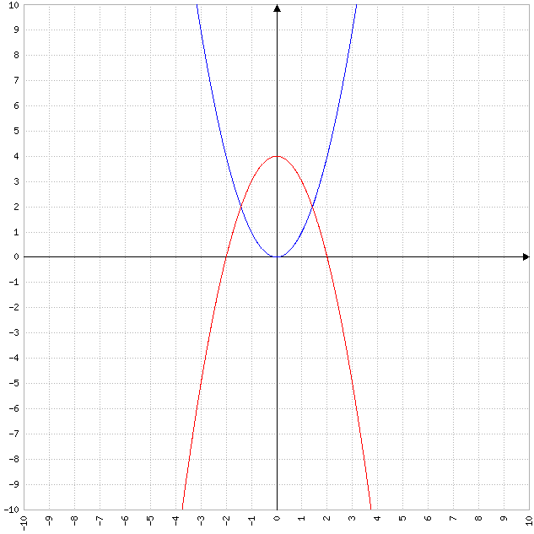

f (x)= g (x)

$x^{2}$ = - $x^{2}$ + 4

+ = 4

2 $x^{2}$ = 4

$x^{2}$ = $\frac{4}{2}$

$x^{2}$ = 2

$\sqrt{x^{2}}$ = $\sqrt{2}$

$\left|x\right|$ = $\sqrt{2}$

x= $±$ $\sqrt{2}$.

|  |  |
| --- | --- |
| **Intervalo** | **(- $\sqrt{2}$, $\sqrt{2}$)** |
| VP | 0 |
| f (x) | 0 |
| g (x) | 4 |

A= $\int_{-\sqrt{2}}^{\sqrt{2}}{g (x)-f (x) dx}$

A= $\int_{-\sqrt{2}}^{\sqrt{2}}{(-x^{2}+4)-x^{2} dx}$

A= $\int_{-\sqrt{2}}^{\sqrt{2}}{-x^{2}+4-x^{2} dx}$

A= $\int_{-\sqrt{2}}^{\sqrt{2}}{-2x^{2}+4 dx}$

A= $\int_{-\sqrt{2}}^{\sqrt{2}}{-2x^{2} dx}$ + $\int_{-\sqrt{2}}^{\sqrt{2}}{4 dx}$

A= -2 $\int_{-\sqrt{2}}^{\sqrt{2}}{x^{2} dx}$ + 4 $\int_{-\sqrt{2}}^{\sqrt{2}}{1 dx}$

A= -2 $\frac{x^{3}}{3}$ $|_{-\sqrt{2}}^{\sqrt{2}}$ + 4x $|_{-\sqrt{2}}^{\sqrt{2}}$

A= $\frac{-2}{3}$ [ ${(\sqrt{2})}^{3}$- ${(-\sqrt{2})}^{3}$] + 4 [ $\sqrt{2}$- (- $\sqrt{2}$)]

A= $\frac{-2}{3}$ [ ${(\sqrt{2})}^{3}$ + ${(\sqrt{2})}^{3}$] + 4 ( $\sqrt{2}$ + $\sqrt{2}$)

A= $\frac{-2}{3}$* 2 ${(\sqrt{2})}^{3}$ + 4 * 2 $\sqrt{2}$

A= $\frac{-4}{3}$ ${(\sqrt{2})}^{2}$ $\sqrt{2}$ + 8 $\sqrt{2}$

A= $\frac{-4}{3}$* 2 $\sqrt{2}$ + 8 $\sqrt{2}$

A= $\frac{-8}{3}$ $\sqrt{2}$ + 8 $\sqrt{2}$

A= $\frac{16}{3}$ $\sqrt{2}$.

**(b)** *f (x)= $x^{4}$ y g (x)= x.*

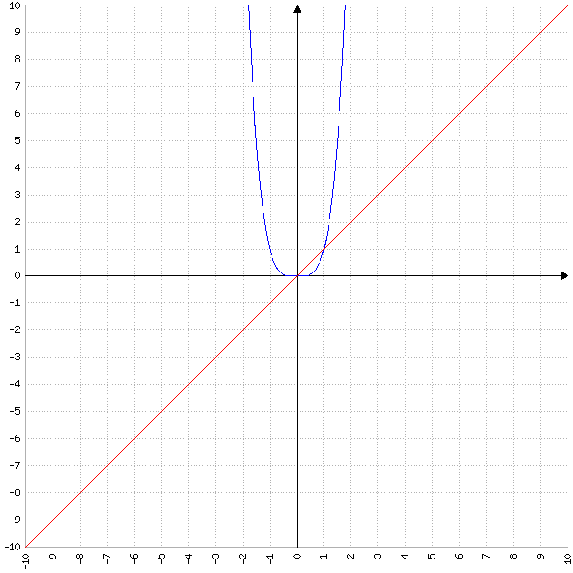

f (x)= g (x)

$x^{4}$ = x

- x= 0

$x^{3}$ (x - 1)= 0.

$x_{1}$ = 0; $x_{2}$ = 1.

|  |  |
| --- | --- |
| **Intervalo** | **(0, 1)** |
| VP | $$\frac{1}{2}$$ |
| f (x) | $$\frac{1}{16}$$ |
| g (x) | $$\frac{1}{2}$$ |

A= $\int_{0}^{1}{g (x)-f (x) dx}$

A= $\int_{0}^{1}{x-x^{4} dx}$

A= $\int_{0}^{1}{x dx}$ + $\int_{0}^{1}{-x^{4} dx}$

A= $\frac{x^{2}}{2}$ $|_{0}^{1}$- $\int_{0}^{1}{x^{4} dx}$

A= $\frac{1}{2}$ ( $1^{2}$- $0^{2}$) - $\frac{x^{5}}{5}$ $|_{0}^{1}$

A= $\frac{1}{2}$ (1 - 0) - $\frac{1}{5}$ ( $1^{5}$- $0^{5}$)

A= $\frac{1}{2}$* 1 - $\frac{1}{5}$ (1 - 0)

A= $\frac{1}{2}$- $\frac{1}{5}$* 1

A= $\frac{1}{2}$- $\frac{1}{5}$

A= $\frac{3}{10}$.

**(c)** *f (x)= $x^{3}$ + $\frac{1}{4}$ x y g (x)= $\frac{1}{2}$ x.*

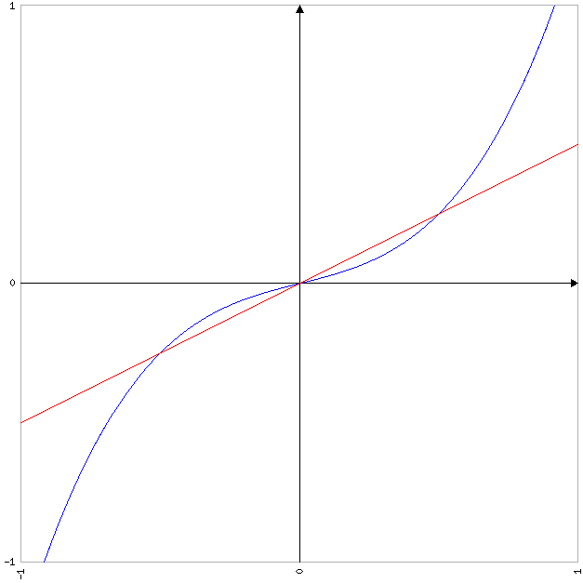

f (x)= g (x)

+ x= $\frac{1}{2}$ x

+ x - $\frac{1}{2}$ x= 0

-  x= 0

x ( $x^{2}$- $\frac{1}{4}$)= 0.

$x_{1}$ = 0; $x_{2}$ = $\frac{-1}{2}$; $x_{3}$ = $\frac{1}{2}$.

|  |  |  |
| --- | --- | --- |
| **Intervalo** | **($\frac{-1}{2}$, 0)** | **(0, $\frac{1}{2}$)** |
| VP | $$\frac{-1}{4}$$ | $$\frac{1}{4}$$ |
| f (x) | $$\frac{-5}{64}$$ | $$\frac{5}{64}$$ |
| g (x) | $$\frac{-1}{8}$$ | $$\frac{1}{8}$$ |

A= $\int_{\frac{-1}{2}}^{0}{f (x)-g (x) dx}$ + $\int_{0}^{\frac{1}{2}}{g (x)-f (x) dx}$

A= $\int_{\frac{-1}{2}}^{0}{(x^{3}+\frac{1}{4}x)-\frac{1}{2}x dx}$ + $\int_{0}^{\frac{1}{2}}{\frac{1}{2}x-(x^{3}+\frac{1}{4}x) dx}$

A= $\int_{\frac{-1}{2}}^{0}{x^{3}+\frac{1}{4}x-\frac{1}{2}x dx}$ + $\int_{0}^{\frac{1}{2}}{\frac{1}{2}x-x^{3}-\frac{1}{4}x dx}$

A= $\int_{\frac{-1}{2}}^{0}{x^{3}-\frac{1}{4}x dx}$ + $\int_{0}^{\frac{1}{2}}{-x^{3}+\frac{1}{4}x dx}$

A= $\int_{\frac{-1}{2}}^{0}{x^{3} dx}$ + $\int_{\frac{-1}{2}}^{0}{\frac{-1}{4}x dx}$ + $\int_{0}^{\frac{1}{2}}{-x^{3} dx}$ + $\int_{0}^{\frac{1}{2}}{\frac{1}{4}x dx}$

A= $\int_{\frac{-1}{2}}^{0}{x^{3} dx}$- $\frac{1}{4}$ $\int_{\frac{-1}{2}}^{0}{x dx}$- $\int_{0}^{\frac{1}{2}}{x^{3} dx}$ + $\frac{1}{4}$ $\int_{0}^{\frac{1}{2}}{x dx}$

A= $\frac{x^{4}}{4}$ $|_{\frac{-1}{2}}^{0}$- $\frac{1}{4}$ $\frac{x^{2}}{2}$ $|_{\frac{-1}{2}}^{0}$- $\frac{x^{4}}{4}$ $|_{0}^{\frac{1}{2}}$ + $\frac{1}{4}$ $\frac{x^{2}}{2}$ $|_{0}^{\frac{1}{2}}$

A= $\frac{1}{4}$ [ $0^{4}$- ${(\frac{-1}{2})}^{4}$] - $\frac{1}{8}$ [ $0^{2}$- ${(\frac{-1}{2})}^{2}$] - $\frac{1}{4}$ [ ${(\frac{1}{2})}^{4}$- $0^{4}$] + $\frac{1}{8}$ [ ${(\frac{1}{2})}^{2}$- $0^{2}$]

A= $\frac{1}{4}$ (0 - $\frac{1}{16}$) - $\frac{1}{8}$ (0 - $\frac{1}{4}$) - $\frac{1}{4}$ ( $\frac{1}{16}$- 0) + $\frac{1}{8}$ ( $\frac{1}{4}$- 0)

A= $\frac{1}{4}$ ($\frac{-1}{16}$) - $\frac{1}{8}$ ($\frac{-1}{4}$) - $\frac{1}{4}$ $\frac{1}{16}$ + $\frac{1}{8}$ $\frac{1}{4}$

A= $\frac{-1}{64}$ + $\frac{1}{32}$- $\frac{1}{64}$ + $\frac{1}{32}$

A= $\frac{1}{32}$.

**Ejercicio 5.**

*Calcular el área de la región comprendida entre el eje x y el gráfico de la función f (x)= - $x^{2}$- 1 entre -2 $≤$ x $≤$-1.*

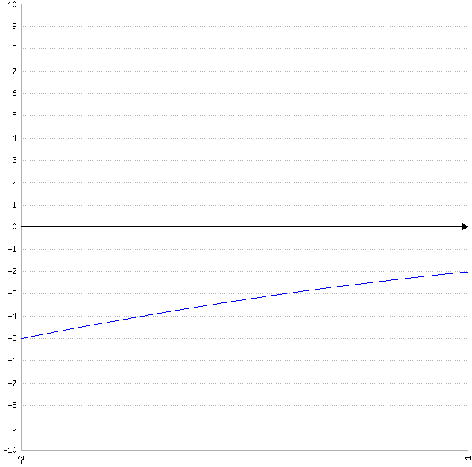

f (x)= 0

- - 1= 0

$x^{2}$ $≠$-1.

|  |  |
| --- | --- |
| **Intervalo** | **(-2, -1)** |
| VP | $$\frac{-3}{2}$$ |
| f (x) | $<$ 0 |

A= - $\int_{-2}^{-1}{-x^{2}-1 dx}$

A= -( $\int_{-2}^{-1}{-x^{2} dx}$ + $\int_{-2}^{-1}{-1 dx}$)

A= -(- $\int_{-2}^{-1}{x^{2} dx}$- $\int_{-2}^{-1}{1 dx}$)

A= -( $\frac{-x^{3}}{3}$ $|_{-2}^{-1}$- x $|_{-2}^{-1}$)

A= -{ $\frac{-1}{3}$ [ ${(-1)}^{3}$- ${(-2)}^{3}$] - [-1 - (-2)]}

A= -{ $\frac{-1}{3}$ [-1 - (-8)] - (-1 + 2)}

A= -[ $\frac{-1}{3}$ (-1 + 8) - 1]

A= -( $\frac{-1}{3}$* 7 - 1)

A= -( $\frac{-7}{3}$- 1)

A= -($\frac{-10}{3}$)

A= $\frac{10}{3}$.

**Ejercicio 6.**

*Calcular el área de la región comprendida entre el eje x y el gráfico de la función f (x)= $x^{2}$ + 2x - 3 entre -1 $≤$ x $≤$ 2.*

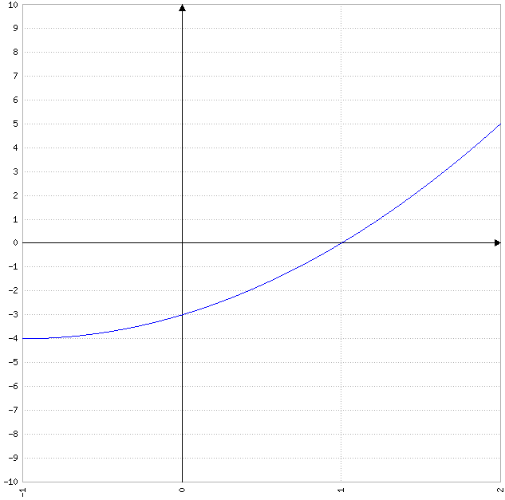

f (x)= 0

+ 2x - 3= 0.

$x_{1}$, $x_{2}$ = $\frac{-2±\sqrt{2^{2}-4*1(-3)}}{2*1}$

$x_{1}$, $x_{2}$ = $\frac{-2±\sqrt{4+12}}{2}$

$x_{1}$, $x_{2}$ = $\frac{-2±\sqrt{16}}{2}$

$x_{1}$, $x_{2}$ = $\frac{-2±4}{2}$

$x_{1}$ = $\frac{-2+4}{2}$ = $\frac{2}{2}$ = 1.

$x_{2}$ = $\frac{-2-4}{2}$ = $\frac{-6}{2}$ = -3.

|  |  |  |
| --- | --- | --- |
| **Intervalo** | **(-1, 1)** | **(1, 2)** |
| VP | 0 | $$\frac{3}{2}$$ |
| f (x) | $<$ 0 | $>$ 0 |

A= - $\int_{-1}^{1}{x^{2}+2x-3 dx}$ + $\int_{1}^{2}{x^{2}+2x-3 dx}$

A= -( $\int_{-1}^{1}{x^{2} dx}$ + $\int_{-1}^{1}{2x dx}$ + $\int_{-1}^{1}{-3 dx}$) + ( $\int_{1}^{2}{x^{2} dx}$ + $\int_{1}^{2}{2x dx}$ + $\int_{1}^{2}{-3 dx}$)

A= -( $\frac{x^{3}}{3}$ $|_{-1}^{1}$ + 2 $\int_{-1}^{1}{x dx}$- 3 $\int_{-1}^{1}{1 dx}$) + ( $\frac{x^{3}}{3}$ $|_{1}^{2}$ + 2 $\int_{1}^{2}{x dx}$- 3 $\int_{1}^{2}{1 dx}$)

A= -{ $\frac{1}{3}$ [ $1^{3}$- ${(-1)}^{3}$] + 2 $\frac{x^{2}}{2}$ $|_{-1}^{1}$- 3x $|_{-1}^{1}$} + [ $\frac{1}{3}$ ( $2^{3}$- $1^{3}$) + 2 $\frac{x^{2}}{2}$ $|_{1}^{2}$- 3x $|_{1}^{2}$]

A= -{ $\frac{1}{3}$ [1 - (-1)] + [ $1^{2}$- ${(-1)}^{2}$] - 3 [1 - (-1)]] + [ $\frac{1}{3}$ (8 - 1) + ( $2^{2}$- $1^{2}$) - 3 (2 - 1)]

A= -[ $\frac{1}{3}$ (1 + 1) + (1 - 1) - 3 (1 + 1)] + [ $\frac{1}{3}$* 7 + (4 - 1) - 3 * 1]

A= -( $\frac{1}{3}$* 2 + 0 - 3 * 2) + ( $\frac{7}{3}$ + 3 - 3)

A= -( $\frac{2}{3}$ + 0 - 6) + $\frac{7}{3}$

A= -($\frac{-16}{3}$) + $\frac{7}{3}$

A= $\frac{16}{3}$ + $\frac{7}{3}$

A= $\frac{23}{3}$.

**Ejercicio 7.**

*Calcular el área de la región comprendida entre los gráficos de f (x)= $x^{2}$ + 1 y g (x)= 2 $x^{2}$ para 0 $≤$ x $≤$ 2.*

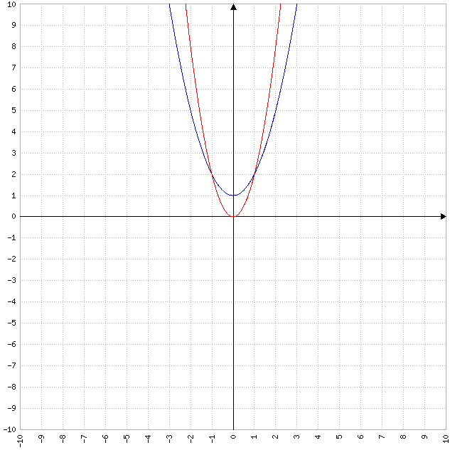

f (x)= g (x)

+ 1= 2 $x^{2}$

2 $x^{2}$- $x^{2}$ = 1

$x^{2}$ = 1

$\sqrt{x^{2}}$ = $\sqrt{1}$

$\left|x\right|$ = 1

x= $±$ 1.

|  |  |
| --- | --- |
| **Intervalo** | **(-1, 1)** |
| VP | 0 |
| f (x) | 1 |
| g (x) | 0 |

A= $\int_{-1}^{1}{(x^{2}+1)-2x^{2} dx}$

A= $\int_{-1}^{1}{x^{2}+1-2x^{2} dx}$

A= $\int_{-1}^{1}{-x^{2}+1 dx}$

A= $\int_{-1}^{1}{-x^{2} dx}$ + $\int_{-1}^{1}{1 dx}$

A= - $\int_{-1}^{1}{x^{2} dx}$ + x $|_{-1}^{1}$

A= $\frac{-x^{3}}{3}$ $|_{-1}^{1}$ + [1 - (-1)]

A= $\frac{-1}{3}$ [ $1^{3}$- ${(-1)}^{3}$] + (1 + 1)

A= $\frac{-1}{3}$ [1 - (-1)] + 2

A= $\frac{-1}{3}$ (1 + 1) + 2

A= $\frac{-1}{3}$* 2 + 2

A= $\frac{-2}{3}$ + 2

A= $\frac{4}{3}$.

**Ejercicio 8.**

*Hallar f (x) sabiendo que f´ (x)= x + $\frac{1}{x^{2}}$ y f (1)= 1.*

f (x)= $\int{f´ (x) dx}$

f (x)= $\int{x+\frac{1}{x^{2}} dx}$

f (x)= $\int{x dx}$ + $\int{\frac{1}{x^{2}} dx}$

f (x)= $\frac{x^{2}}{2}$ + $\int{x^{-2} dx}$

f (x)= $\frac{x^{2}}{2}$ + $\frac{x^{-1}}{-1}$

f (x)= $\frac{1}{2}$ $x^{2}$- $\frac{1}{x}$ + C.

f (1)= 1

$\frac{1}{2}$ $1^{2}$* - $\frac{1}{1}$ + C= 1

$\frac{1}{2}$* 1 - 1 + C= 1

- 1 + C= 1

+ C= 1

C= 1 + $\frac{1}{2}$

C= $\frac{3}{2}$.

f (x)= $\frac{1}{2}$ $x^{2}$- $\frac{1}{x}$ + $\frac{3}{2}$.

**Ejercicio 9.**

*Sabiendo que f´ (x)= 3 $x^{2}$- 8x + 2 y, además, que f (3)= -4, hallar la función f (x).*

f (x)= $\int{f´ (x) dx}$

f (x)= $\int{3x^{2}-8x+2 dx}$

f (x)= $\int{3x^{2} dx}$ + $\int{-8x dx}$ + $\int{2 dx}$

f (x)= 3 $\int{x^{2} dx}$- 8 $\int{x dx}$ + 2 $\int{1 dx}$

f (x)= 3 $\frac{x^{3}}{3}$- 8 $\frac{x^{2}}{2}$ + 2x

f (x)= $x^{3}$- 4 $x^{2}$ + 2x + C.

f (3)= -4

- 4 $3^{2}$* + 2 * 3 + C= -4

27 - 4 * 9 + 6 + C= -4

27 - 36 + 6 + C= -4

-3 + C= -4

C= -4 + 3

C= -1.

f (x)= $x^{3}$- 4 $x^{2}$ + 2x - 1.

**Ejercicio 10.**

*Hallar todas las funciones cuya derivada es g´ (x)= $x^{2}$ cos x.*

g (x)= $\int{g´ (x) dx}$

g (x)= $\int{x^{2}\cos{x}dx}$

g (x)= $x^{2}$ sen x - $\int{sen x*2x dx}$ (*)

g (x)= $x^{2}$ sen x - 2 $\int{x sen x dx}$

g (x)= $x^{2}$ sen x - 2 [x (-cos x) - $\int{-\cos{x}dx}$] (**)

g (x)= $x^{2}$ sen x - 2 (-x cos x + $\int{\cos{x}dx}$)

g (x)= $x^{2}$ sen x - 2 (-x cos x + sen x)

g (x)= $x^{2}$ sen x - 2x cos x - 2 sen x

g (x)= ( $x^{2}$- 2) sen x - 2x cos x + C.

(*) u= $x^{2}$; du= 2x dx; dv= cos x dx; v= sen x.

(**) u= x; du= dx; dv= sen x; v= -cos x.

**Ejercicio 11.**

*Sea g´´ (x)= 2 $x^{3}$- 4 $x^{7}$, g´ (1)= -2 y g (0)= 0, hallar la función g (x).*

g´ (x)= $\int{g´´ (x) dx}$

g´ (x)= $\int{2x^{3}-4x^{7} dx}$

g´ (x)= $\int{2x^{3} dx}$ + $\int{-4x^{7} dx}$

g´ (x)= 2 $\int{x^{3} dx}$- 4 $\int{x^{7} dx}$

g´ (x)= 2 $\frac{x^{4}}{4}$- 4 $\frac{x^{8}}{8}$

g´ (x)= $\frac{1}{2}$ $x^{4}$- $\frac{1}{2}$ $x^{8}$

g´ (x)= $\frac{1}{2}$ ( $x^{4}$- $x^{8}$) + C.

g´ (1)= -2

$\frac{1}{2}$ ( $1^{4}$- $1^{8}$) + C= -2

$\frac{1}{2}$ (1 - 1) + C= -2

$\frac{1}{2}$* 0 + C= -2

0 + C= -2

C= -2.

g´ (x)= $\frac{1}{2}$ ( $x^{4}$- $x^{8}$) - 2.

g (x)= $\int{g´ (x) dx}$

g (x)= $\int{\frac{1}{2}(x^{4}-x^{8})-2 dx}$

g (x)= $\int{\frac{1}{2}x^{4}-\frac{1}{2}x^{8}-2 dx}$

g (x)= $\int{\frac{1}{2}x^{4} dx}$ + $\int{\frac{-1}{2}x^{8} dx}$ + $\int{-2 dx}$

g (x)= $\frac{1}{2}$ $\int{x^{4} dx}$- $\frac{1}{2}$ $\int{x^{8} dx}$- 2 $\int{1 dx}$

g (x)= $\frac{1}{2}$ $\frac{x^{5}}{5}$- $\frac{1}{2}$ $\frac{x^{9}}{9}$- 2x

g (x)= $\frac{1}{10}$ $x^{5}$- $\frac{1}{18}$ $x^{9}$- 2x + C.

g (0)= 0

- - 2 * 0 + C= 0

$\frac{1}{10}$* 0 - $\frac{1}{18}$* 0 - 0 + C= 0

0 - 0 - 0 + C= 0

C= 0.

g (x)= $\frac{1}{10}$ $x^{5}$- $\frac{1}{18}$ $x^{9}$- 2x.